C PROGRAMMING MINI PROJECT

DOCUMENTATION

PROJECT TITLE : CONTACT MANAGEMENT SYSTEM

STUDENT NAME : AZHAGUMATHI.S

REGSISTER NUMBER : 921724115008

DEPARTMENT : COMPUTER SCIENCE AND DESIGN

COLLEGE NAME : SETHU INSTITUTE OF TECHNOLOGY

COURSE : PROGRAMMING IN C

TRAINER NAME : Mr.B.BALAJI

SUBMISSION DATE : 26/02/2026

ABSTRACT :
The Contact Management System is a simple C program used to store and manage contact details such as name and phone number. The problem it solves is organizing and maintaining contact information efficiently instead of writing them manually on paper.
The program works using arrays and structures to store contact details. It displays a menu where the user can add, view, search, and delete contacts. Based on the user’s choice, the program processes the data and displays the output.

INTRODUCTION :

Problem Statement
Managing contacts manually is difficult and time-consuming. There is a need for a simple digital system to store and retrieve contact details easily.

Why This Project is Useful
- Helps organize contact details.
- Reduces manual record keeping.
- Easy to search and manage data.

Where It Can Be Used
- Personal contact storage
- Small office contact management
- Academic learning projects

OBJECTIVES ;
• To understand the concept of structured programming in C.
• To learn how to use structures for storing contact details.
• To implement arrays for managing multiple records.
• To use loops for repeating menu operations.
• To apply conditional statements (if, switch) for decision making.
• To develop a menu-driven program.
• To improve logical thinking and problem-solving skills.
• To understand basic data management operations like add, search, view, and delete.

TOOLS & TECHNOLOGY:
• Programming Language: C
• Compiler: GCC / Turbo C / Code::Blocks
• Platform: Windows / Linux
• Development Tool: Any IDE or Text Editor

SYSTEM REQUIERMENTS:

Hardware:
- Basic computer with minimum 4GB RAM

Software:
- C Compiler
- Any IDE or Text Editor

METHODOLOGY / ALGORITHM:

Step 1: Start the program

Step 2: Declare structure Contact
- Variables: name, phone

Step 3: Declare an array of structure to store contacts

Step 4: Initialize contact count to 0

Step 5: Display the main menu:
- Add Contact
- View Contacts
- Search Contact
- Delete Contact
- Exit

Step 6: Read user choice

Step 7: Use switch-case to perform operations

Case 1: Add Contact
- Check if contact list is full
- If not full:
  - Read name
  - Read phone number
  - Store in array
  - Increase count by 1

Case 2: View Contacts
- If count is 0:
  - Display "No contacts available"
- Else:
  - Display all stored contacts

Case 3: Search Contact
- Read name to search
- Compare with each stored contact
- If match found:
  - Display contact details
- Else:
  - Display "Contact not found"

Case 4: Delete Contact
- Read name to delete
- Search for matching contact
- If found:
  - Shift remaining contacts left
  - Decrease count by 1
- Else:
  - Display "Contact not found"

Case 5: Exit
- Stop the program

Step 8: Repeat steps 5–7 until user selects Exit

Step 9: End the program

FLOW CHART:
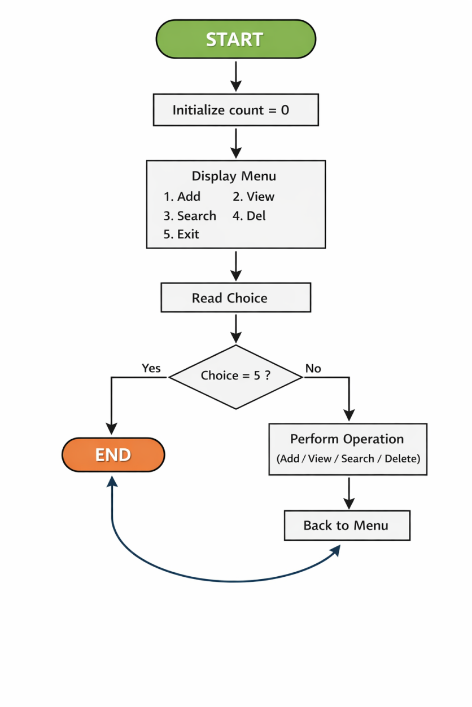

PROGRAM CODE:
#include <stdio.h>
#include <string.h>
#define MAX 100
struct Contact {
char name[50];
char phone[15];
};
struct Contact contacts[MAX];
int count = 0;
void addContact() {
if(count >= MAX) {
printf("Contact list is full!\n");
return;
}
printf("Enter Name: ");
scanf("%s", contacts[count].name);
printf("Enter Phone Number: ");
scanf("%s", contacts[count].phone);
count++;
printf("Contact Added Successfully!\n");
}
void viewContacts() {
if(count == 0) {
printf("No contacts available.\n");
return;
}

printf("\n--- Contact List ---\n");
for(int i = 0; i < count; i++) {
printf("Name: %s\n", contacts[i].name);
printf("Phone: %s\n", contacts[i].phone);
printf("-------------------\n");
}
}
void searchContact() {
char searchName[50];
printf("Enter name to search: ");
scanf("%s", searchName);
for(int i = 0; i < count; i++) {
if(strcmp(contacts[i].name, searchName) == 0) {
printf("Contact Found!\n");
printf("Name: %s\n", contacts[i].name);
printf("Phone: %s\n", contacts[i].phone);
return;
}
}
printf("Contact not found.\n");
}

void deleteContact() {
char deleteName[50];
printf("Enter name to delete: ");
scanf("%s", deleteName);
for(int i = 0; i < count; i++) {
if(strcmp(contacts[i].name, deleteName) == 0) {
for(int j = i; j < count - 1; j++) {
contacts[j] = contacts[j + 1];
}
count--;
printf("Contact Deleted Successfully!\n");
return;
}
}
printf("Contact not found.\n");
}
int main() {
int choice;
do {
printf("\n--- Contact Management System ---\n");
printf("1. Add Contact\n");
printf("2. View Contacts\n");
printf("3. Search Contact\n");
printf("4. Delete Contact\n");
printf("5. Exit\n");
printf("Enter your choice: ");
scanf("%d", &choice);
switch(choice) {
case 1:
addContact();
break;
case 2:
viewContacts();
break;
case 3:
searchContact();
break;
case 4:
deleteContact();
break;
case 5:
printf("Exiting Program...\n");
break;
default
printf("Invalid choice!\n");
}
} while(choice != 5);
return 0;
}

SAMPLE INPUT/OUTPUT;

--- Contact Management System ---
1. Add Contact
2. View Contacts
3. Search Contact
4. Delete Contact
5. Exit
Enter your choice: 1
Enter Name: MATHI
Enter Phone Number: 1234098761
Contact Added Successfully!
--- Contact Management System ---
1. Add Contact
2. View Contacts
3. Search Contact
4. Delete Contact
5. Exit
Enter your choice: 2
--- Contact List ---
Name: MATHI
Phone: 1234098761
-------------------

RESULT:
The Contact Management System program was successfully implemented using C language.
All operations such as add, view, search, and delete contacts were executed correctly.
The program works as expected without errors.

APPLICATIONS:
- Used to store and manage personal contact details.
- Helpful for small offices to maintain employee or client records.
- Useful for students to understand basic data management concepts.
- Can be used as a base for developing advanced phonebook applications.
- Suitable for academic projects and lab practice.

CONCLUSION:
The Contact Management System was successfully developed using the C programming language. The project demonstrates the use of structures, arrays, loops, and conditional statements in a menu-driven program.
It helps in understanding basic data handling operations such as adding, viewing, searching, and deleting records. The system works efficiently and fulfills the intended objectives of managing contact details digitally.

FUTURE ENHANCEMENTS:
• Add file handling to store contacts permanently (data saved even after program closes).
• Implement update/edit contact option.
• Add sorting feature (sort contacts alphabetically).
• Improve the user interface for better readability.
• Add password protection for security.
• Increase storage capacity using dynamic memory allocation.
• Convert it into a GUI-based application.

REFERENCES:
- E. Balagurusamy, “Programming in ANSI C”, McGraw Hill Education.
- Online C Programming Tutorials and Documentation.

